EXP-01

AIM:
To create a web page that embeds a map with hotspots, frames, and links. The web page should be designed using HTML, incorporating embedded, external, and inline CSS for styling. This exercise aims to enhance understanding of integrating multimedia elements like maps, creating interactive hotspots, and organizing content using frames while applying different CSS techniques for styling.

ALGORITHM:
Create the HTML structure:
- Set up the basic HTML document with <!DOCTYPE html>, <html>, <head>, and <body> tags.
- In the <head>, link the external CSS file (<link> tag), define the title, and include any metadata.
- In the <body>, create the necessary elements:
  - Frames: Use the <frameset> tag to create a frame layout (for older browsers, use <iframe> instead).
  - Map: Use the <img> tag to display a map.
  - Hotspots: Create clickable regions using the <map> and <area> tags.
  - Links: Add hyperlinks (<a>) to navigate to different parts of the page or external sites.

Create CSS Styles:
- External CSS: In a separate file, define styles such as colors, fonts, and layout for the entire page.
- Inline CSS: Use the style attribute within specific tags to apply styles (e.g., in <div> or <p> tags).
- Embedded CSS: Inside the <style> tag in the <head>, define styles for specific elements like the map, frames, and text.
Map with Hotspots:
- Use the <map> tag to create an image map.
- Define the <area> tag for each hotspot, specifying the coordinates (e.g., coords="x,y,x2,y2") for clickable areas on the map.
Frames:
- Use the <iframe> tag for embedding external content like a map or another webpage, with attributes such as src for the URL, width, and height.
Add Links:
- Inside the <body>, use the <a> tag to create links for navigation (for example, to link to specific parts of the page or external sites).
Test the Page:
- Test the webpage to check the functionality of frames, hotspots, and links. Ensure that the map hotspots are clickable and the linked content displays correctly.
- Ensure that the styles are applied properly using inline, embedded, and external CSS.

Program:
Index.html:

<!DOCTYPE html>
<html>
<head>
<title>Online Voting System</title>

<!-- External CSS -->
<link rel="stylesheet" href="style.css">

<!-- Embedded CSS -->
<style>
p {
color: green;
text-align: center;
font-size: 16px;
}
</style>
</head>

<!-- Inline CSS -->
<body style="background-color:#ad8ba5;">

<h1>Online Voting System</h1>

<div class="container">
<p>Click on the voting image to view party symbols</p>
</div>

<br>

<!-- IMAGE MAP WITH HOTSPOT -->
<center>
<img src="vote1.webp" width="300" usemap="#votemap">

<map name="votemap">
<area shape="rect" coords="0,0,150,150"
href="party1.png" target="frame1" alt="Party 1">
<area shape="rect" coords="150,0,300,150"
href="party2.png" target="frame1" alt="Party 2">
</map>
</center>

<br>

<!-- FRAME TO SHOW IMAGE -->
<center>
<iframe name="frame1" width="300" height="200"
style="border:1px solid black;">
</iframe>
</center>

<br><br>

<!-- EMBEDDED MAP USING IFRAME -->
<h3>Election Office Location</h3>

<center>
<iframe
src="https://www.google.com/maps?q=Election%20Commission%20of%20India&output=embed"
width="500"
height="250"
style="border:1px solid black;">
</iframe>
</center>

</body>
</html>

Style.css:

body {
font-family: bold;
font-style: italic;
background-color: #f2f2f2;
}

h1, h3 {
text-align: center;
color: darkblue;
}

.container {
width: 200px;
margin: auto;
padding: 5px;
background-color: rgb(186, 239, 255);
border: 2px solid black;
}

Output:
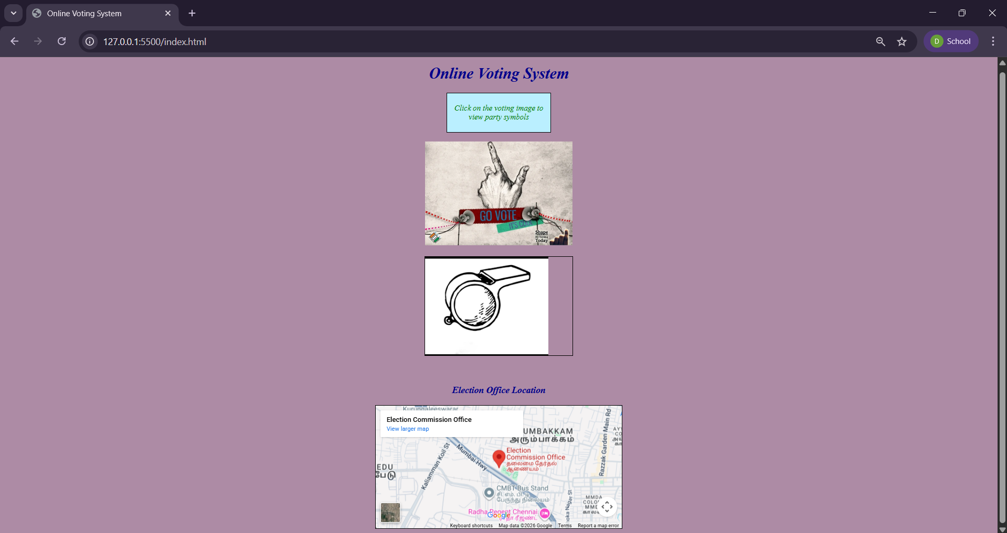

Result:
Html Page is created with embedded Chennai map along with hot spot, frames & links.

